

**INTERNET OF THINGS ASSIGNMENT 1**

**NAME: M.HARSHINI**

**REG.NO: 121011012776**

**COURSE NAME: INTERNET OF THINGS**

**MQTT PROTOCOL:**

MQTT, which stands for Message Queuing Telemetry Transport, is a lightweight, publish-subscribe network protocol that transports messages between devices. Designed for low-bandwidth, high-latency or unreliable networks, MQTT is ideal for Internet of Things (IoT) applications where network efficiency and lightweight data packets are essential. The protocol, standardized by the OASIS and ISO (ISO/IEC 20922), ensures messages are delivered efficiently and securely, even in constrained environments.

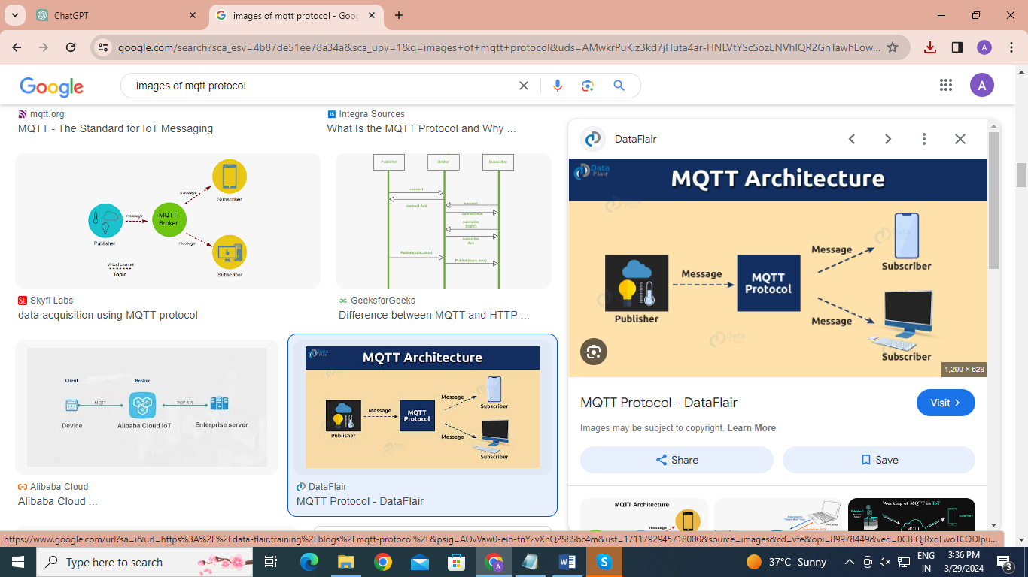

**Key Features of MQTT:**

1. **Lightweight Protocol**: It is designed to minimize network traffic and resource requirements, making it suitable for devices with limited processing power and memory.
2. **Publish/Subscribe Model**: MQTT operates on a publish/subscribe model, enabling decoupled communication between devices. Publishers send messages to a topic, and subscribers receive messages by subscribing to that topic.
3. **Quality of Service (QoS) Levels**: MQTT supports three levels of QoS to manage message delivery guarantees:
4. QoS 0 (At most once): The message is delivered at most once, with no confirmation.
5. QoS 1 (At least once): The message is delivered at least once, with confirmation required.
6. QoS 2 (Exactly once): Ensures the message is delivered exactly once by using a four-step handshake.
7. **Retained Messages**: Publishers can mark a message as "retained" to be stored and sent to any future subscribers that subscribe to that topic.
8. **Last Will and Testament (LWT)**: Allows a client to publish a message to a specified topic if the client disconnects unexpectedly, which is useful for notifying other clients about the disconnection.
9. **Security:** While MQTT itself is a lightweight protocol, it can be secured with TLS/SSL to ensure secure connections between clients and the broker. Additionally, authentication mechanisms can be implemented at the application level.

**How MQTT Works:**

**Connection Establishment:** An MQTT client establishes a connection with an MQTT broker by specifying the broker's URL and port. Security mechanisms like SSL/TLS and client credentials (username and password) can be used during this phase.

**Publish/Subscribe Mechanism:** After the connection is established, clients can subscribe to topics or publish messages to topics. The MQTT broker is responsible for filtering messages and distributing them to subscribed clients based on the topic of the message.

**Message Exchange:** Clients communicate indirectly through the broker by publishing messages to topics. The broker ensures the delivery of messages to all subscribers of those topics according to the specified QoS level.

**Disconnect:** Clients can disconnect from the broker once their session is complete. Optionally, they can set up a Last Will and Testament message to notify others in case of unexpected disconnection.

**Advantages**

**1.Efficiency:** MQTT is designed to be lightweight, which makes it ideal for constrained environments where network bandwidth and battery power are limited.

**2.Low Bandwidth Consumption:** It uses minimal data packets, which reduces the amount of data transmitted over the network, thereby conserving bandwidth.

**3.Decoupled Communication:** The publish/subscribe model allows for decoupled communication between devices, meaning the publisher and subscriber don't need to know about each other, leading to more scalable and flexible architectures.

**4.Quality of Service (QoS) Levels:** MQTT offers three levels of QoS, enabling tailored message delivery guarantees according to the needs of the application.

**5.Last Will and Testament (LWT):** This feature allows devices to notify others about an unexpected disconnection, which is crucial for monitoring device connectivity and status.

**6.Secure Communication:** While lightweight, MQTT can be secured with SSL/TLS, ensuring encrypted communication channels.

**Disadvantages**

**1.Broker Dependency:** The central broker model can become a single point of failure if not managed or scaled properly. High availability and redundancy mechanisms must be implemented to mitigate this risk.

**2.Security Overhead:** While MQTT can be secured with TLS/SSL, implementing these security measures can add overhead, particularly in very constrained environments.

**3.Complex QoS Handling:** Implementing and managing the higher levels of QoS (1 and 2) can introduce complexity, especially in maintaining the state and handling retries in unreliable networks.

**4.Broker Performance:** In scenarios with a large number of devices, the performance of the MQTT broker can become a bottleneck. Scalability and broker performance need to be considered in large-scale deployments.

**Applications**

**1.IoT Devices:** MQTT is widely used in IoT for connecting various sensors, actuators, and smart devices due to its efficiency and ease of deployment.

**2.Telemetry:** In industries like agriculture, oil and gas, and manufacturing, MQTT is used for telemetry data collection from remote sensors, enabling real-time monitoring and control.

**3.Smart Homes:** It is used in smart home platforms for communicating between smart devices, such as lights, thermostats, and security systems, facilitating automation and remote control.

**4.Vehicle Telematics:** MQTT is used in automotive and transport applications for vehicle telematics, including real-time location tracking, vehicle diagnostics, and driver behavior monitoring.

**5.Healthcare**: In healthcare, MQTT facilitates remote patient monitoring by connecting wearable devices and medical sensors to central monitoring systems.

**6.Energy Management:** MQTT is employed in energy management systems for monitoring and controlling energy consumption in buildings and industrial plants.

**CoAP PROTOCOL:**

Constrained Application Protocol (CoAP) is a web transfer protocol designed for use in constrained nodes and networks, making it highly suitable for the Internet of Things (IoT) applications. CoAP is defined in RFC 7252 by the Internet Engineering Task Force (IETF). It is designed to easily translate to HTTP for simplified integration with the web while also meeting specialized requirements such as multicast support, very low overhead, and simplicity for constrained environments.

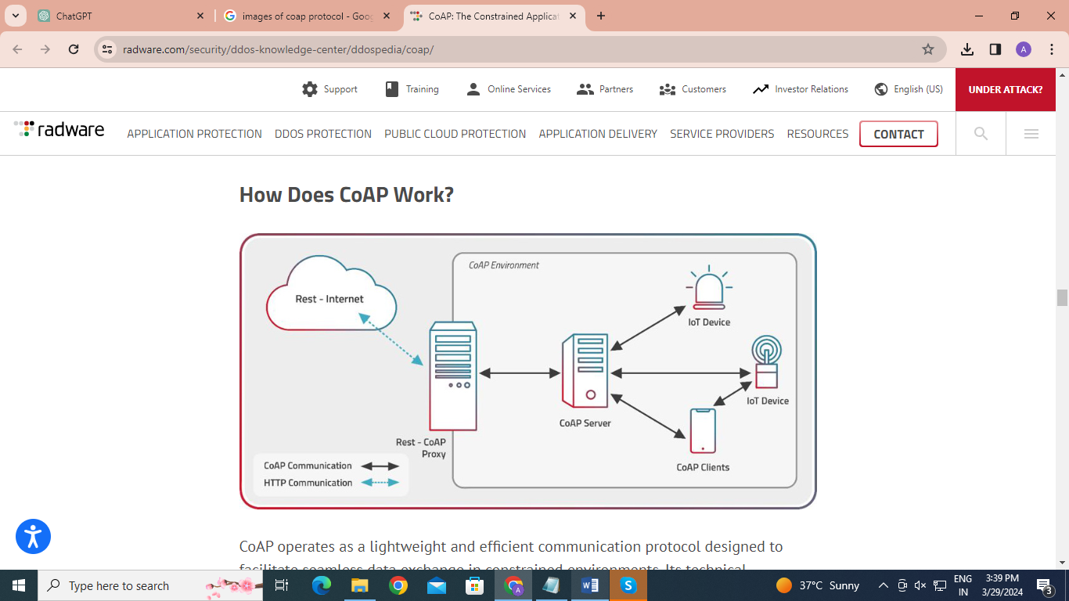

**Key Features of CoAP:**

1. **Lightweight:** CoAP is designed to be simple and easy to implement, requiring minimal resources, which makes it ideal for constrained devices, such as IoT sensors and actuators.
2. **UDP-Based:** CoAP runs on top of the User Datagram Protocol (UDP), allowing for low overhead and minimizing the resources needed for communication. It can also work over Datagram Transport Layer Security (DTLS) to provide secure communications.
3. **RESTful Design:** It follows a Representational State Transfer (REST) architecture similar to HTTP, using methods like GET, POST, PUT, and DELETE for interactions with resources identified by URIs, making it familiar to developers and easy to interface with web technologies.
4. **Asynchronous Message Exchange:** CoAP supports both confirmable and non-confirmable message exchanges, allowing for reliable delivery (with acknowledgements) and "fire-and-forget" scenarios, respectively.
5. **Support for Multicast:** CoAP uniquely supports multicast requests, which can be particularly useful for simultaneous interactions with multiple devices, such as discovering devices or issuing group commands in IoT networks.
6. **Built-in Discovery:** CoAP includes resource discovery mechanisms, enabling devices to discover services and resources provided by other devices in the network.
7. **Blockwise Transfers:** CoAP can handle the exchange of large resources in a constrained environment by splitting them into smaller blocks, facilitating more efficient data transmission.

**How CoAP Works:**

**UDP Foundation**: CoAP is built on top of UDP (User Datagram Protocol), making it lighter than TCP-based protocols. UDP's simplicity allows CoAP to maintain low overhead and resource requirements, which is crucial for constrained devices.

**Request/Response Model:** It employs a simple request/response model that is similar to HTTP, using methods such as GET, POST, PUT, and DELETE to interact with resources identified by URIs.

**Message Exchange:** CoAP messages can be confirmable (CON) or non-confirmable (NON). Confirmable messages ensure reliability through acknowledgments (ACKs), whereas non-confirmable messages are used for "fire-and-forget" scenarios, where reliability isn't critical.

**Observing Resources:** CoAP allows clients to "observe" resources and receive updates whenever the state of the resource changes, facilitating efficient real-time notifications without the need for constant polling.

**Security:** CoAP can be secured with Datagram Transport Layer Security (DTLS), providing encryption, authentication, and integrity verification over UDP.

**Multicast Support:** CoAP supports multicast requests, enabling efficient group communication and device discovery without the need for individual requests to each device.

**Blockwise Transfers:** For transferring large payloads that exceed the payload size limit, CoAP supports blockwise transfers, where the data is split into smaller, manageable blocks.

**Advantages :**

1. **Resource-Efficient:** Its lightweight design makes it suitable for devices with limited computational power and memory, as well as networks with low bandwidth.
2. **Easy Integration with the Web**: CoAP is designed to easily integrate with HTTP for web applications, enabling direct interaction between constrained IoT devices and the broader web ecosystem.
3. **Real-Time Communications:** The observe mechanism in CoAP allows devices to subscribe to resource changes, enabling efficient and real-time communications without the overhead of frequent polling.
4. **Reliable Transmission:** CoAP's support for confirmable messages ensures reliability in message delivery, crucial for many IoT applications, while also providing flexibility with non-confirmable messages when appropriate.
5. **Secure:** With DTLS, CoAP offers a secure communication channel, ensuring data confidentiality, integrity, and authentication in IoT applications.
6. **Efficient Multicast:** CoAP's support for multicast enables efficient service discovery and group communication, reducing network traffic and resource consumption.
7. **Interoperability**: CoAP's RESTful architecture and standardized protocol ensure interoperability among IoT devices and systems, facilitating a cohesive and integrated IoT ecosystem.

**Disadvantages:**

1. **UDP Limitations:** Being based on UDP, CoAP does not inherently provide the reliability and order of message delivery that TCP does. Although CoAP has mechanisms to ensure message delivery, these add complexity when handling reliability manually.
2. **Security:** While DTLS provides a mechanism for securing CoAP communications, implementing and managing DTLS in highly constrained environments can be challenging and resource-intensive.
3. **Fragmentation:** In cases where packet sizes exceed the network's maximum transmission unit (MTU), there can be issues with fragmentation, potentially leading to increased complexity and reduced efficiency.

**Applications:**

1. **Smart Home and Building Automation:** CoAP is used for communication between smart devices in home and building automation systems, enabling efficient control and monitoring of lighting, temperature, and energy usage.
2. **Environmental Monitoring:** In environmental monitoring, CoAP facilitates the collection of data from sensors distributed across wide geographic areas, such as temperature, humidity, and pollution levels.
3. **Healthcare:** CoAP is applied in healthcare for patient monitoring systems, where it helps in transmitting data from wearable health devices and sensors to central monitoring systems.
4. **Agriculture:** It supports agricultural technologies, including soil moisture sensors and climate control systems in greenhouses, optimizing water use and improving crop yield.
5. **Industrial Automation**: CoAP is utilized in industrial IoT applications for machine-to-machine (M2M) communication, enabling remote control, monitoring, and maintenance of industrial equipment.

**HTTP PROTOCOL:**

HTTP, or Hypertext Transfer Protocol, is the foundation of data communication on the World Wide Web. Developed by Tim Berners-Lee at CERN in 1989-1990, HTTP functions as a request-response protocol in the client-server computing model. Web browsers, acting as clients, submit HTTP requests to servers, which then return responses. Over the years, HTTP has evolved through several versions, with HTTP/1.1 and HTTP/2 being widely used, and HTTP/3 being the latest development, focusing on improving speed and efficiency by running over QUIC.

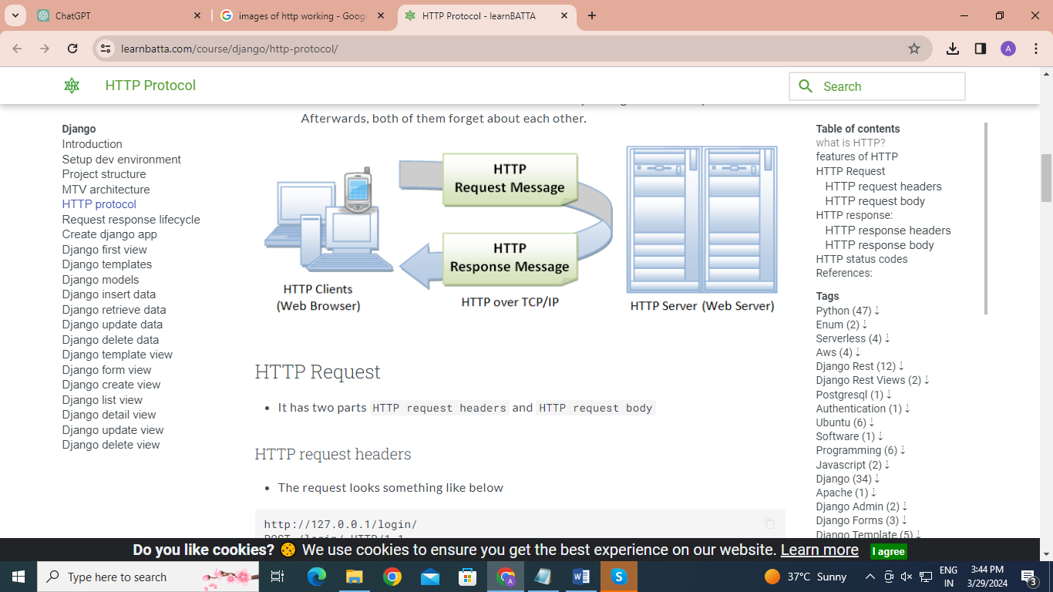

**Key Features of HTTP:**

1. **Stateless Protocol:** HTTP is stateless, meaning each request-response pair is independent; servers do not retain session information between different requests from the same client. This simplicity enables the scalability of web services, although cookies and session storage are used to overcome this limitation for user experience enhancement.
2. **TCP/IP Connection:** Traditionally, HTTP uses TCP (Transmission Control Protocol) at the transport layer to ensure reliable communication. HTTP/3, the upcoming version, uses QUIC, which is built on top of UDP (User Datagram Protocol) and aims to improve performance issues related to TCP.
3. **Client-Server Model:** HTTP operates on a client-server model, where web browsers or other clients make requests to servers, which then process these requests and return the appropriate responses.
4. **Request/Response Structure:** Each HTTP request and response includes a start-line, headers, and an optional body. The start-line in a request specifies the method (e.g., GET, POST), while in a response, it includes the status code (e.g., 200 OK, 404 Not Found).
5. **Versatile:** HTTP is used to transfer data of any type, such as HTML documents, images, videos, and other types of web resources, making it a versatile and widely adopted protocol.

**Working of HTTP**

HTTP works based on a request-response protocol in the client-server model.

**User Action:** The process typically begins with a user action, like typing a URL into a browser’s address bar or clicking on a web link.

**DNS Lookup:** The browser performs a DNS lookup to translate the domain name into an IP address, which identifies the server on the internet.

**Establishing a Connection:** The browser establishes a TCP connection to the server (HTTP/3 uses QUIC, which is based on UDP). For HTTPS, a TLS handshake also occurs here to secure the connection.

**Sending the HTTP Request:** The browser sends an HTTP request to the server. This request includes a request line (with the method, URL, and HTTP version), headers (with additional information like the browser type), and sometimes a body (for methods like POST).

**Server Processing:** The server processes the request, which may involve retrieving or modifying resources, interacting with databases, or performing other actions.

**Sending the HTTP Response:** The server sends back an HTTP response, which includes a status line (with the status code and reason phrase), headers (with information like content type), and a body containing the requested resource or data.

**Closing the Connection:** Once the response is fully received, the connection is typically closed. With HTTP/1.1, keep-alive connections can be used to send multiple requests over a single connection. HTTP/2 further improves efficiency with features like multiplexing.

**Rendering:** The browser interprets the received data, typically rendering it as a web page. Additional resources (like CSS, JavaScript, and images) may be requested in subsequent HTTP transactions.

**Advantages :**

1. **Simplicity and Flexibility:** HTTP is straightforward to implement and use, offering flexibility in the types of data and resources that can be transferred over the web.
2. **Extensibility:** HTTP headers allow the protocol to be extended and customized for different applications, including authentication, caching, content negotiation, and more.
3. **Ubiquity:** As the fundamental protocol of the Web, HTTP is supported by virtually all internet infrastructure and web development frameworks, ensuring broad compatibility.
4. **Statelessness:** While statelessness is seen as a limitation in some contexts, it also allows HTTP to scale efficiently, as servers do not need to maintain information about past client requests.

**Disadvantages:**

1. **Security:** The basic HTTP does not encrypt data, making it vulnerable to eavesdropping and man-in-the-middle attacks. HTTPS (HTTP Secure) addresses this by using TLS (Transport Layer Security) to encrypt communications.
2. **Statelessness:** For applications requiring persistent information about user sessions, HTTP's stateless nature requires additional mechanisms, like cookies, which can complicate design and implementation.
3. **Performance:** HTTP/1.1 can suffer from latency issues due to its text-based format and the way it handles connections (one request per connection). HTTP/2 and HTTP/3 introduce improvements like multiplexing and header compression to address these issues.

**Applications :**

1. **Web Browsing:** The most common use of HTTP is in web browsing, where it facilitates the transfer of web pages, images, videos, and other content from web servers to clients’ browsers.
2. **APIs and Web Services:** HTTP is heavily used for APIs, especially RESTful APIs, where it enables communication between clients and services over the web. This supports a multitude of applications, including social media platforms, e-commerce transactions, and cloud services.
3. **Data Transfer:** Beyond web pages, HTTP is used for transferring files and data between clients and servers. This includes downloading software, streaming video and audio, and uploading content to social media.
4. **IoT Devices**: In the Internet of Things (IoT), HTTP is used for devices to communicate with servers and each other over the internet. While not as lightweight as protocols like MQTT or CoAP, it’s used where HTTP’s infrastructure and compatibility are advantageous.
5. **Webhooks:** Many services use HTTP webhooks to trigger actions or notifications. For example, a webhook might notify a service when a new post is published on a blog or a transaction occurs in an online store.

**AMQP PROTOCOL:**

AMQP, or the Advanced Message Queuing Protocol, is an open standard application layer protocol for message-oriented middleware. Unlike many messaging systems that are built on a proprietary system or custom protocol, AMQP is designed for interoperability between different systems and organizations. It was introduced to enable reliable and secure messaging between applications or systems, regardless of their internal architectures, platforms, or languages.

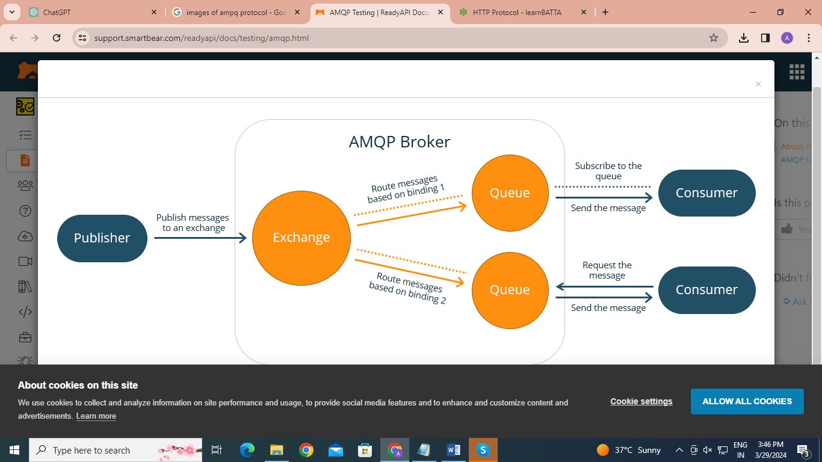

**How AMQP Works**

**Connection Establishment:** Initially, an AMQP client establishes a connection with an AMQP broker (server). This connection is a TCP/IP connection secured optionally by TLS for encryption and authentication.

**Channel Creation:** Once the connection is established, the client can create one or more channels. A channel is a virtual connection inside the physical TCP connection, allowing for multiple concurrent streams of communication on a single connection.

**Message Publishing:** The producer (sending application) publishes a message to an exchange within the broker. The message contains a payload (the data being sent) and headers (metadata about the message). The producer specifies a routing key that determines how the message will be routed.

**Message Routing:** The exchange receives the message and routes it to the appropriate queue(s) based on the type of exchange, the routing key, and the binding rules defined between exchanges and queues.

**Message Consumption:** Consumer applications subscribe to queues to receive messages. The broker then delivers messages from the queue to the consumer. Consumers can acknowledge messages once processed, ensuring messages are not lost if a consumer fails.

**Acknowledgment and Reliability:** AMQP supports message acknowledgments, meaning a message is not removed from the queue until it's explicitly acknowledged by a consumer, ensuring reliable delivery.

**Advantages**

1. **Interoperability:** As an open standard, AMQP ensures interoperability between different systems and applications, making it ideal for integrating diverse software environments.
2. **Reliability:** Through features like message acknowledgment, durable queues, and transactions, AMQP provides mechanisms to ensure messages are not lost, even in the event of connection failures or consumer application crashes.
3. **Security:** AMQP supports strong security mechanisms, including authentication and encryption through TLS. This makes it suitable for scenarios where secure data transmission is critical.
4. **Flexible Routing:** AMQP's model of exchanges, queues, and bindings offers powerful and flexible message routing capabilities. This allows for sophisticated messaging patterns, including publish/subscribe, request/reply, and more.
5. **Scalability:** AMQP's design supports scalable messaging solutions, enabling efficient communication in systems ranging from small IoT deployments to large-scale enterprise applications.

**Disadvantages**

1. **Complexity:** The flexibility and range of features offered by AMQP can also lead to complexity in configuration and management, particularly for simple messaging needs.
2. **Overhead:** The additional features and reliability mechanisms can introduce overhead, potentially impacting performance compared to lighter-weight messaging protocols.

**Applications**

1. **Enterprise Application Integration:** Facilitating communication and data exchange between different enterprise systems or applications.
2. **Cloud Services:** Enabling messaging between cloud-based services and applications, both within and across cloud environments.
3. **Financial Services:** Supporting reliable and secure transactions and data transfers in financial applications and systems.
4. **IoT:** Although not as lightweight as some IoT-focused protocols (like MQTT or CoAP), AMQP is used in some IoT scenarios where its reliability and security features are required.
5. **Supply Chain and Logistics:** Managing communication and coordination across complex supply chains that involve multiple organizations and systems.